WRITE YOUR TITLE HERE (All caps, Roboto 14, Bold)
Author 1^{1*} and Author 2²
¹Afffilation (Complete Name of Institution and Address)
²Affiliation (Complete Name of Institution and Address)
*Corresponding author: email@address.com

ABSTRACT – Write your abstract here. Words should be 200 to 300 words. Abstract should be in one column. Justified. Roboto (Font size 12).

Keywords: Keyword 1, Keyword 2, Keyword 3, etc.

INTRODUCTION (For headings, use all caps text format, Roboto 12, Bold)
(For normal text use Roboto 11, 6pt spacing before and after the paragraph, Justified) Lorem ipsum dolor sit amet, consectetur adipiscing elit. Maecenas vel erat vel sem porttitor tincidunt. Aenean quis leo non lorem tristique mattis. Phasellus in pharetra velit, nec semper tortor. Nullam eu augue non elit rutrum scelerisque sit amet eu purus. Aliquam tincidunt, odio a vestibulum rhoncus, orci sem fringilla felis, sit amet ornare nisl nibh vitae tortor. Duis orci tellus, mattis ut justo vel, dignissim eleifend ligula.

METHODOLOGY
(For normal text use Roboto 11, 6pt spacing before and after the paragraph, Justified) Lorem ipsum dolor sit amet, consectetur adipiscing elit. Maecenas vel erat vel sem porttitor tincidunt. Aenean quis leo non lorem tristique mattis. Phasellus in pharetra velit, nec semper tortor. Nullam eu augue non elit rutrum scelerisque sit amet eu purus. Aliquam tincidunt, odio a vestibulum rhoncus, orci sem fringilla felis, sit amet ornare nisl nibh vitae tortor. Duis orci tellus, mattis ut justo vel, dignissim eleifend ligula.

RESULTS AND DISCUSSION
Subheading 1 (For subheading 1, use Roboto 11, Bold)
Subheading 2 (For subheading 2, use Roboto 11, Bold, Italics)
(For normal text use Roboto 11, 6pt spacing before and after the paragraph, Justified) Lorem ipsum dolor sit amet, consectetur adipiscing elit. Maecenas vel erat vel sem porttitor tincidunt. Aenean quis leo non lorem tristique mattis. Phasellus in pharetra velit, nec semper tortor. Nullam eu augue non elit rutrum scelerisque sit amet eu purus. Aliquam tincidunt, odio a vestibulum rhoncus, orci sem fringilla felis, sit amet ornare nisl nibh vitae tortor. Duis orci tellus, mattis ut justo vel, dignissim eleifend ligula.
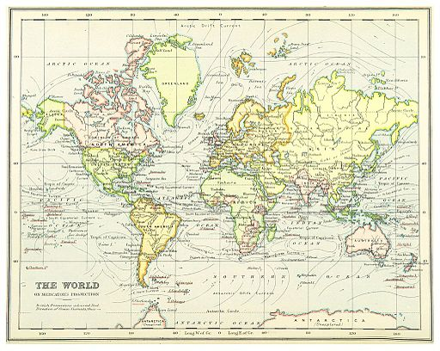
Figure 1. Map of the World
(If applicable, cite source in APA format) Source: Irvine. (1899). Map of the world [Photograph]. Wikimedia Commons. https://upload.wikimedia.org/wikipedia/commons/8/8d/%281899%29_MAP_OF_THE_WORLD_-_comp._by_Irvine.jpg
Table 1
Table Title
Heading 1 | Heading 2 | Heading 3 | Heading 4
Row 1
Row 2
Row 3
Row 4
Row 5
Row 6

CONCLUSION AND RECOMMENDATIONS
(For normal text use Roboto 11, 6pt spacing before and after the paragraph, Justified) Lorem ipsum dolor sit amet, consectetur adipiscing elit. Maecenas vel erat vel sem porttitor tincidunt. Aenean quis leo non lorem tristique mattis. Phasellus in pharetra velit, nec semper tortor. Nullam eu augue non elit rutrum scelerisque sit amet eu purus. Aliquam tincidunt, odio a vestibulum rhoncus, orci sem fringilla felis, sit amet ornare nisl nibh vitae tortor. Duis orci tellus, mattis ut justo vel, dignissim eleifend ligula.

REFERENCES
(References should be in APA citation format, 6pt spacing before and 12pt spacing after the paragraph, .5 inch Hanging Indent)
Author, A. A., & Author, B. B. (Year). Title of the article. Title of the Journal, volume number(issue number), page range. https://doi.org/xxxxx
Author, A. A., & Author, B. B. (Year). Title of the article. Title of the Journal, volume number(issue number), page range. https://doi.org/xxxxx
Author, A. A., & Author, B. B. (Year). Title of the article. Title of the Journal, volume number(issue number), page range. https://doi.org/xxxxx
Author, A. A., & Author, B. B. (Year). Title of the article. Title of the Journal, volume number(issue number), page range. https://doi.org/xxxxx

